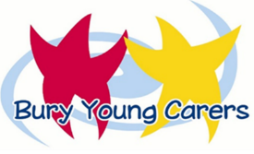

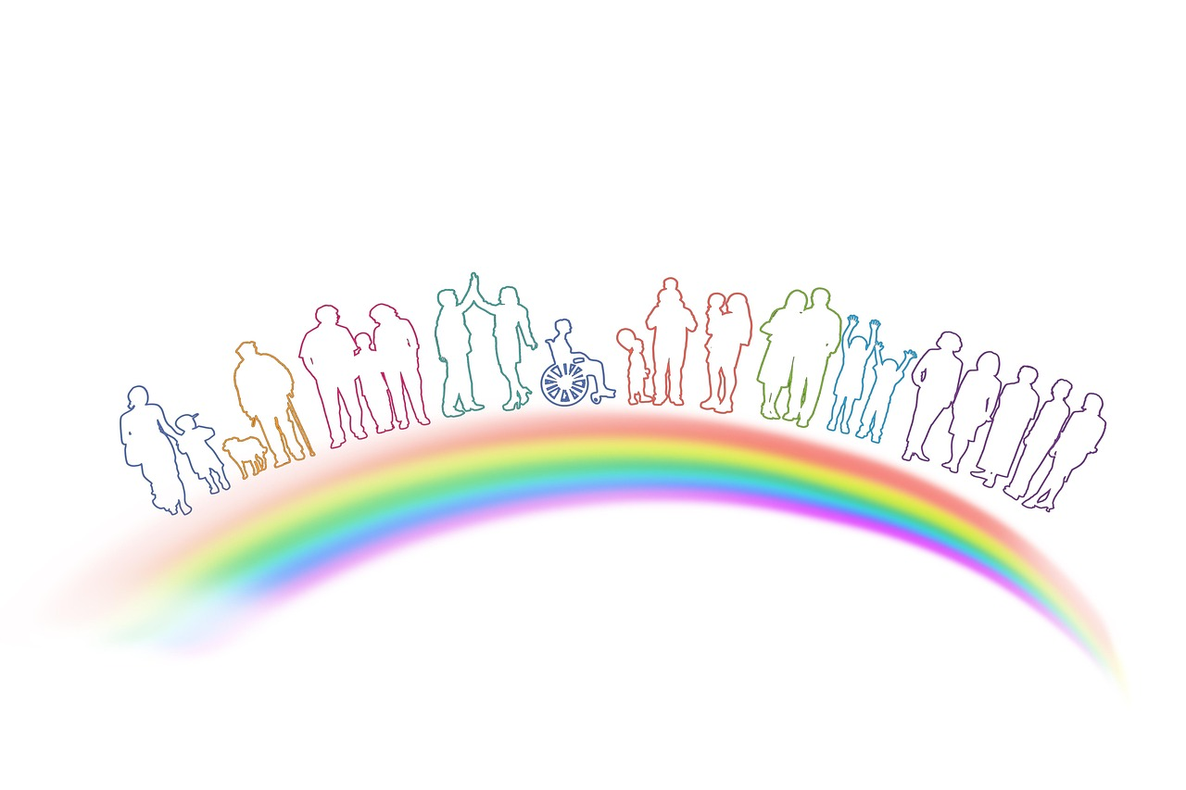
Bury Council

Young Carers Tool Kit: For Professionals
TABLE OF CONTENTS
1. introduction 3
2. how to use the toolkit 5
3. SIGNS AND INDICATORS 6
4. POTENTIAL BARRIERS TO IDENTIFYING YOUNG CARERS 7
5. CONVERSATION STARTERS 9
6. young carers self-assessment tool 15
7. appendix a: conversation starter – word template 17
8. young carers self-assessment tool: for children & Young People 21
9. next steps & fURTHER INFORMATION AND RESOURCES 29
#

- introduction

Young carers are children first and foremost; they have the same rights as all children and young people. Young carers should be able to learn, achieve and enjoy positive, healthy childhoods, just like other children.

Young carers and families are experts on their own lives – they know what is working well and where they may need more support. It falls to professionals across all sectors to actively involve them in shaping the personalised and integrated responses that best meet their needs. This principle applies regardless of whether care needs arise as a result of mental or physical illness, disability, or substance misuse and whether a parent, a sibling or a family member is the focus of support.

The legal definition of a young carer is taken from section 96 of the Children and Families Act 2014: “…a person under 18 who provides or intends to provide care for another person (of any age, except where that care is provided for payment, pursuant to a contract or as voluntary work).”

For us in Bury we define our young carers as; a child under the age of 18 who looks after, supports or cares for a family member (a parent / carer or sibling) who due to illness, disability, mental health or drug and alcohol problems would be unable to cope without their support. A young carer’s day to day responsibilities could include tasks such as:

- Cooking, housework and shopping
- Physical care, such as helping someone out of bed
- Emotional support, such as talking to someone who is distressed
- Personal care, such as helping someone get dressed
- Helping to give medicine
- Making sure the bills are paid

As of March 2025, Bury had 139 children and young people aged between 7 and 18 registered as a young carer. We believe that there are likely more children and young people in our area that could be eligible for an assessment and service from young carers who have not yet been identified.

We know that we need to do more in Bury to support our schools and partners in identifying children who may be a young carer, to ensure that these children have access to the right level of help and intervention they may need. We will work more closely, not only with our schools, but our primary health colleagues, GPs, adults and children’s services to support in the early identification of young carers in our borough.

We have developed this Young Carers Toolkit to raise awareness of young carers, provide information, and to support professionals to identify more young carers – thus helping us to better respond to, and provide the right level of support that these young people may need.

- how to use the toolkit

The toolkit is separated into 8 sections:

- Signs & Indictors that a child or young person is undertaking a caring role
- Barriers to the identification of young carers
- Conversation starters for professionals who believe a child or young person is undertaking a caring role
- Young Carers Self-Assessment Tool
- Appendix A – Record of discussion with a child or young person
- Appendix B – Young Carers Self-Assessment tool
- Next Steps
- Helpful Resources & Further Information for children, young people and families
Where there is a likelihood that a child or young person is a young carer, we recommend that they are spoken to by someone who they trust and feels comfortable with.

We have collated questions that can help start a conversation with a child or young person - this is not meant to be a ‘script’, these are ideas and suggestions for you to use in everyday discussions.

Think about the right time and place to have the conversation so people feel safe and comfortable to talk about their home life.

It is also important to be aware that many parents and young people may be worried about being open about home life due to possible repercussions, such as the information being shared with children’s social care. We should always be transparent about the reasons why we are asking people questions, and that this toolkit is aimed to identify whether a child or young person / their family may benefit from some help and support. Be clear that if the child or young person does tell you something that makes you really worried about them, i.e., disclosures or allegations of harm, then you will have to tell someone but that you would tell them and their parent first (unless to do so would place the child at immediate risk).

signs or indicators that a child or young person may have caring responsibilities

This list is not exhaustive, and some of these behaviours / observations could relate to the child or young person experiencing a multitude of different problems, therefore these are just some of the things to be more curious about:

- They are regularly late to school, and / or they have lots of days off school
- They struggle to complete their homework
- They often appear tired / distracted / unmotivated / have a low attention span in class
- They present as anxious, withdrawn, experience low mood and even engage in self-harming behaviours
- They become upset or angry if their parent / carer needs to be contacted by a professional i.e., school ringing home to report an issue.
- Parents / carers do not attend any scheduled parents’ evenings or other school events.
- The child’s physical presentation and appearance may have changed
- The child regularly attends with their parent for doctors / hospital appointments or is present when adult social care or other adult services visit the parent at home.
- A young person may frequently take and collect younger brothers and sisters from nursery or school.

potential barriers to the identification of young carers

Many young people with caring responsibilities at home often go under the radar at school and college, they may not view themselves as a young carer, they may be embarrassed or too worried to ask for help.

Professionals working with parents where there is physical, learning, mental health or drug and alcohol misuse may not always recognise that a child or young person in the home may be helping or undertaking a caring role for the parent. Equally, a lot of parents may feel embarrassed or ashamed that their child is having to undertake some level of caring responsibility for them.

We know that early identification of young carers is vital. Often young carers don’t get identified until a crisis happens. The sooner we can find out someone is a young carer, the more support can be put in place to enable them to have the same opportunities as their peers, be protected from inappropriate caring roles, and to keep them safe, happy, successful, and healthy.

Professionals are encouraged to be curious about children living in a home where an adult has a disability or learning need or even experiencing mental health or substance misuse issues. We have created some questions to help you to start a conversation which can be done on a one-to-one basis, or in a small group setting if appropriate. Remember, children’s and families’ situations change, and therefore our advice is to regularly check in and keep discussions current to respond in a timely and effective way to changing need.

conversation starters

We have put together some questions that may support you to start a conversation with a child or young person to explore whether they are undertaking a caring role within the home. You will develop your own style based on your knowledge, skills and experience and therefore these are purely a guide for you to tweak and develop!
We have included some conversation starters and questions with some guidance notes.

Conversation Starters / Questions | Guidance
I wanted to have a quick chat to ask how you are. I’ve noticed that (see signs and indicators listed above), and I just wanted to check if you are okay or if there is anything we can do? | Think about what you have seen, heard or observed that leads you to be curious about a child or young person undertaking a caring role.
Sometimes when things are happening at home it can affect every other area of our lives, I know that things have been a bit difficult for you over the past couple of weeks, and wanted to check in with you to see how you are, or if you would like to talk about anything? | Relate this to what you have seen, heard or observed and share these with the child or young person.
(Where you are aware of historical parental difficulties / illness etc.) I just wanted to see how things were going at home, I know that things have not always been easy for you at home, and I have noticed (insert behaviour / signs as appropriate), so I just wanted to see whether these problems are happening again? | Use this type of question when you know that the child or young person has had previous difficulties at home.
We have been a little bit worried recently as you have been (insert behaviour / signs as appropriate), we just wanted to check with you how things are at home? E.g., I know that you have been having to take your little brother to school and pick him up which is making you late for school, do you want to talk about that? | Use this type of conversation starter where you have been alerted to a possibility that the child or young person is a young carer based on recent observations, interactions or discussions.
Talk to me about what it is like for you at home at the moment, are you having to do more at home? What are the things that you are doing to help your mum / dad / grandparent etc.? | This could be practical things like cooking, cleaning, looking after younger brothers or sisters, self-care, providing personal care to a parent / carer, managing the family finances and money, providing emotional support, giving medicine or providing emergency help or first aid.
Is there anyone else at home who helps out? Or anyone who doesn’t live at home who helps look after you and your family? | This is really important to explore as if they are a sole carer, or have a lot of caring responsibilities they might be very isolated, and have limited support networks other areas of their lives are likely to be significantly affected. It is also helpful to understand who else in the wider support network, a family member or family friend is doing to help and could potentially do a little more if this was needed.
Do you often think about or worry about your mum / dad / brother / sister etc. when you are not with them? If they answer yes, acknowledge that it must be quite difficult, and think about asking some further questions such as: tell me about how this affects you on a day to day basis? does this distract you and make it hard to concentrate? What are some of the things that worry you most? | Their worries could be around the person they care for falling, not taking their medication, not eating, harming themselves, using drugs or alcohol or not looking after little brothers and sisters if they are at home.  All these worries can make a young person feel anxious, stressed, frustrated, upset, and it is important that their feelings are acknowledged, and that support can be put in place where needed.
How does all of this make you feel? | As with the last question, young carers are likely to feel a range of emotions related to their caring responsibilities so it is really important that they are given the time to talk about these.  For some children and young people, using feelings cards or tools to support this discussion is beneficial.  Many children may not recognise that they are a ‘young carer’ as their role within the family has always been the same and as such 'normal’ to them.  For some children and young people their caring role is a positive experience, they may feel they have a close and special relationship with the adult they are caring for, whilst this may be the case, it is still important that they know what support could be available to them should they need this now or in the future.
Do you get time to yourself to relax, do things for yourself, see friends / do any activities or clubs? Does looking after your mum / dad / other sometimes stop you from being able to do these things? | We know that for a lot of our young carers their caring responsibilities often mean that they don’t get much time to themselves, and that activities and doing things with friends are often impacted which can lead to them feeling isolated, overwhelmed and lonely.
Does caring for mum / dad / other affect your own health and wellbeing? | This question should explore the impact of the caring responsibilities on the child’s own health and wellbeing – for example; recurrent headaches / back pain / difficulty sleeping / eating disorders / depression / low mood / anxiety / panic attacks etc.  Speak to the young person about support available, and ensure that where there are worries raised we are responding to this and putting in plans to help.
How are things going at school / college? Does caring for mum / dad / other affect schooling? | For some young carers, school or college is a break from home and they do really well (although be mindful that particular stressors such as exam periods, transitions, or things getting worse at home could change this – thus reminding us that these are conversations to pick up frequently with our young people)  For others school and college can be particularly difficult, they may often be in trouble for being late or for not completing homework etc. and feel as though the teachers do not understand. Their caring responsibilities may impact on the child or young person being alert, engaged in lessons or in social activities, or their behaviour may be a worry such as them getting easily frustrated or angry which can lead to them getting into trouble.  Children and young people need support, understanding and flexibility at school / college to help them thrive and achieve.  If you are a school professional talk to the young person about what things may help them in school, such as flexibility with homework, how lates can be managed differently, etc.
Do you have anyone you already talk to about caring for mum / dad / other? Would you like someone to talk to? | It is really important to stress that they are not alone and there is support out there if they want this. Talk to them about the local young carers offer, and what a young carers assessment is, and how they can access help and support with other young people who are young carers. There is a lot of resources for young people online about young carers and it may be helpful to look at some of these with the young person.
Any Other Information gathered

As we mentioned earlier, children and young people may be worried that by telling someone about their caring responsibilities, may get their parent / carer into trouble, or result in a social worker becoming involved – this is particularly relevant where a parent is experiencing substance misuse difficulties. It is important to acknowledge this and reassure them that people are there to help them, and their family, and that you will be open and honest with them if you feel so worried that you may need to share this with children’s services.
It is really important to recognise and celebrate what an amazing thing young people are doing as carers. Being in a caring role for someone you love can be difficult no matter what your age, let alone for a child or young person.

It is important to know that this might have been a hard conversation for young person. Ask them if they need anything now and let them know what will happen next. Remember to check how they are again soon – they might feel worried about what they have shared with you afterwards.

- young carers self-assessment tool

The child or young person should be encouraged to complete the Young Carers Self-Assessment tool – this is based on the Multidimensional Assessment of Caring Activities (Joseph, S, Becker, F, and Becker, S, 2009. It was designed as a short and easy evidence-based tool that was developed and tested with young carers. The questionnaire can be completed independently by most children and young people, however, for younger children and / or those with some level of additional needs they may need support from you as a professional, or from their parent / carer to complete it.
Please see appendix B for a copy of the Young Carers Self-Assessment tool – and the link for the online form.
Following the child or young person completing the self-assessment tool (see appendix B), please speak to the child or young person to answer the following questions.
Question | Answer
What do you want to happen next?

Can you talk to your parent / carer about your caring role? | Yes No
Would you like a referral to Young Carers Support Service for additional support? | Yes No
Who would it be useful to tell anyone else about being a young carer?

Are there any other professionals that you would like support from?

Who will you let know if things get worse?

Would you like us to check in with you within 6 months? | Yes No

- appendix a: conversation starter – word template
Remember these are only prompts and you may want to ask your own questions to explore whether a child or young person is undertaking a caring role. Some of the questions may not be relevant and therefore do not feel you have to answer every section.

Conversation Starters / Questions | Child or Young Person’s responses
I wanted to have a quick chat to ask how you are. I’ve noticed that (see signs and indicators listed above), and I just wanted to check if you are okay or if there is anything we can do?

Sometimes when things are happening at home it can affect every other area of our lives, I know that things have been a bit difficult for you over the past couple of weeks, and wanted to check in with you to see how you are, or if you would like to talk about anything?

(Where you are aware of historical parental difficulties / illness etc.) I just wanted to see how things were going at home, I know that things have not always been easy for you at home, and I have noticed (insert behaviour / signs as appropriate), so I just wanted to see whether these problems are happening again?

We have been a little bit worried recently as you have been (insert behaviour / signs as appropriate), we just wanted to check with you how things are at home? E.g., I know that you have been having to take your little brother to school and pick him up which is making you late for school, do you want to talk about that?

Talk to me about what it is like for you at home at the moment, are you having to do more at home? What are the things that you are doing to help your mum / dad / grandparent etc.?

Is there anyone else at home who helps out? Or anyone who doesn’t live at home who helps look after you and your family?

Do you often think about or worry about your mum / dad / brother / sister etc. when you are not with them? If they answer yes, acknowledge that it must be quite difficult, and think about asking some further questions such as: tell me about how this affects you on a day to day basis? does this distract you and make it hard to concentrate? What are some of the things that worry you most?

How does all of this make you feel?

Do you get time to yourself to relax, do things for yourself, see friends / do any activities or clubs? Does looking after your mum / dad / other sometimes stop you from being able to do these things?

Does caring for mum / dad / other affect your own health and wellbeing?

How are things going at school / college? Does caring for mum / dad / other affect schooling?
Do you have anyone you already talk to about caring for mum / dad / other? Would you like someone to talk to?

Any Other Information gathered

Following the child or young person completing the self-assessment tool (see appendix B), please speak to the child or young person to answer the following questions.
Question | Answer
What do you want to happen next?

Can you talk to your parent / carer about your caring role? | Yes No
Would you like a referral to Young Carers Support Service for additional support? | Yes No
Who would it be useful to tell anyone else about being a young carer?

Are there any other professionals that you would like support from?

Who will you let know if things get worse?

Would you like us to check in with you within 6 months? | Yes No

- young carers self-assessment tool: for children & Young People

This is a template of the self-assessment tool for you to use, or you can complete our online form here: LINK

You may want to do this by yourself, or you may find it helpful to do it with a professional you trust, or even your parent / carer.

Introduction

Young carers are those under the age of 18 who looks after, supports or cares for a family member (a parent / carer or sibling) who due to illness, disability, mental health or drug and alcohol problems would be unable to cope without their support. A young carer’s day to day responsibilities could include tasks such as:

- Cooking, housework and shopping
- Physical care, such as helping someone out of bed
- Emotional support, such as talking to someone who is distressed
- Personal care, such as helping someone get dressed
- Helping to give medicine
- Making sure the bills are paid

We have designed this tool as a way for you to think about some of the tasks and responsibilities you may have at home that could mean that you are a young carer. It also helps us to consider the support that may be helpful for you or the person you care for if you want this.

Name:

Age:

School:

Who lives at home with you?

Your contact details
(mobile number or email)

Your parent / carers contact details
(mobile number or email)
If you are completing this form with someone can you tell us who they are?
(e.g. your teacher Mrs Smith)

Who do you help look after or care for? (tick as many boxes that apply to you)

Mum | Dad | Brother(s) / Sister(s)
Grandparent(s) | Other family members | Friend or Other

Why do you need to look after them? (tick as many boxes that apply)

They have a physical disability  (for example they are unable to walk and use a wheelchair, they are deaf or visually impaired, difficulties with mobility and doing day to day tasks) | They have a long-term illness  (for example fibromyalgia, live with chronic pain, have chronic fatigue, heart problems, cancer, epilepsy or many other)
Substance misuse  (for example, they drink alcohol or take other drugs – these may be illegal or sometimes prescribed by a dr and they are struggling to stop. The alcohol / drugs may take priority in the home and can impact on how they behave and feel which can be unpredictable sometimes) | They have a learning disability  (this may mean that they attend a special education provision, they struggle with reading, writing, or understanding things)
They have mental health problems  (for example, they can find life very challenging due to having depression, anxiety, feel they cannot leave the home, or have diagnosed condition such as schizophrenia or a personality disorder) | They are neuro divergent  (e.g. Autistic, ADHD)
Sensory impairment  (For example, sight hearing, smell, touch, taste and spatial awareness in no longer normal) | They are ill in another way

The following section will ask you about some of the tasks that you may do at home. Each of the items are rated on a 3-point scale, ‘Never/ rarely’, ‘Some of the time’ and ‘A lot of the time’.

For scoring purposes:

- ‘Never/ rarely’ = 0
- ‘Some of the time’ = 1
- ‘A lot of the time’ = 2

The score provides a summary of caring activity by totalling all 30 items. The lowest score is 0 and the highest score is 60.

Below are some jobs that young carers do to help. Please read each one and put a tick in the box to show how often you have done each of the jobs in the past month.

 | Never/ Rarely | Some of the time | A lot of the time | Add any comments to explain more if you want
Household Jobs
Clean your own bedroom
Clean other rooms
Cooking and preparing food
Helping the person you care for eat / drink
Wash up / dry dishes, use dishwasher
Doing the laundry
Putting clothes away / ironing
Decorate rooms
Take responsibility for the food shopping
Help with lifting or carrying heavy things
Dealing with money and finances:
Help with financial matters such as dealing with bills, banking, money, or collecting benefits
Work part time to bring money in
Looking after the cared for person:
Interpret, sign of use other communication system for the person you care for
Help the person you care for to dress or undress
Help the person you care for have a wash
Help the person you care for to have a bath or shower
Helping the person you care for to use the toilet
Helping the person you care for to get around the home including up the stairs.
Offering emotional support to the person you care for (e.g., giving them a hug when they are down, listening to them when they are upset, do you try to make them laugh)
Help give medication
Keep the person you care for company (e.g., sitting with them, reading to them, talking to them)
Keep an eye on the person you care for to make sure they are alright
Take the person you care for out (e.g., for a walk, to see friends or relatives)
Looking after brothers or sisters
Taking brothers or sisters to school
Looking after your brothers and sisters when another adult is near by
Look after brothers or sisters on your own
Go to doctors / hospital / other appointments with the person you care for
Be at home if a professional is coming to visit the person you care for
Administer emergency first aid to the person you care for

If you do anything else to help the person you care for, please add below.

 | Number ticked | Total  (remember ‘lot of the time scores 2 points per tick!)
Number marked never / rarely 0
Number marked some of the time 1
Number marked a lot of the time 2
Overall Score

0 = No caring activity recorded
1-9 = Low amount of caring activity
10-13 = Moderate amount of caring activity
14-17 = High amount of caring activity
18 and above = Very high amount of caring activity

If you have scored over 10, we recommend that a request for a Young Carers assessment is made.

If you are not completing the form online, please see section below called ‘Next Steps’ that will give you further information.

If you are completing the form online you will be given an option to submit your self-assessment to our Young Carers service who will make, contact with you and your parent / carer to talk to you about what support is available.

- next steps
If your discussion with a child or young person / or their self-assessment indicates that they are a young carer, seek their consent to speak to their parent / carer to discuss a referral into our young carers service.

It is important to let children and families know that the local Young Carers Service is part of Bury’s Early Help offer, you can signpost them or show them our website Young carers - Bury Council and provide them with a copy of our Bury Young Carers leaflet.

A request for support (or sometimes known as a referral) can be made to the Young Carers service by a professional (with parental consent) or by the young person / their parent / carer if you believe that the child or young person may be eligible for a young carers assessment. You can do this via our online form multi-agency-request-for-support-form-may-2024.docx and sending this to Childwellbeing@bury.gov.uk

Families and professionals can also contact our Young Carers Service directly on buryyoungcarers@bury.gov.uk for advice or guidance, however, we are unable to accept requests for support via this option.

If you are a professional from education completing this toolkit it is part of schools’ statutory duty to record young carers and to assess and offer intervention if required. Equally it is every professional’s responsibility to make sure a young carer is identified on individual agencies databases to improve data on identification of young carers, help safeguard and assist in monitoring support.

There is no definition of inappropriate or excessive care, it depends on age and type of care e.g., 10-year-old taking responsibility for feeding family; a young carer helping the cared for wash/ bath or shower all the time; young carer looking after siblings all the time or taking siblings to schools all the time are likely to cause concern.

If you feel that the child or young person’s caring role is inappropriate or excessive then you can contact our young carers service directly at buryyoungcarers@bury.gov.uk or contact our Multi-Agency Safeguarding Hub (MASH) for a consultation on:

Telephone: 0161 253 5678

Email: Childwellbeing@bury.gov.uk

For immediate safeguarding worries please follow the usual process – please see following link: Report a child at risk - Bury Council

- helpful resources & further Information
Name of service | Description | Website / contact
Bury Young Carers Service | Supporting children and young people who have a caring responsibility. Undertake statutory young carers assessments, provide one-to-one support, host workshops, provide free activities and group sessions. | Young carers - Bury Council  Buryyoungcarers@bury.gov.uk
Young Carers Senior Session | A targeted youth group that takes place weekly aimed at providing young carers with a space to connect with other young people, engage in activities, seek support and have a break from their caring responsibilities. | Bury Youth Service (@buryyouthservice) Instagram  Bury Youth Service | Facebook  youthservice@bury.gov.uk
Young Carers Junior Session | A targeted junior youth group that takes place monthly aimed at providing young carers with a space to connect with other young people, engage in activities seek support and have a break from their caring responsibilities. | Bury Youth Service (@buryyouthservice) Instagram  Bury Youth Service | Facebook  youthservice@bury.gov.uk
Young Carer SHINE programme | Fortnightly targeted sessions designed to offer our young carers specific information, advice and guidance on themes that may impact on them because of the caring role they undertake. The SHINE sessions will run twice monthly and can be accessed by invite only to ensure that we have the right group of children and young people attending. If you would like further information please contact Buryyoungcarers@bury.gov.uk | Young carers - Bury Council  Buryyoungcarers@bury.gov.uk
HAF | Holiday, Activities and Food (HAF) is a government programme aimed at supporting children who are eligible for free school meals and those who are deemed as vulnerable access to a range of school holiday activities. | Bury Holiday Activities and Food programme - Bury Council  haf@bury.gov.uk
Bury Youth Service | Providing universal and targeted youth group sessions – operating across Bury, for more information please see our social media pages. | Bury Youth Service (@buryyouthservice) Instagram  Bury Youth Service | Facebook  youthservice@bury.gov.uk
Early Break | Early Break is a charity which is offered borough wide.  It is a service designed to meet the needs of young people and their families with regard to drug and alcohol use/mental health in Bury, Rochdale, Bolton, Salford, Trafford and Oldham. | Home - Early Break - Early Break
First Point Family Support Services | Service for families with children who are neurodiverse and have special educational needs or disabilities (SEND). | Home | First Point Family Support Services
Kooth | Free anonymous text counselling for young people | Home - Kooth
TLC: Talk, Listen, Change | TLC: Talk, Listen, Change is a relationships charity. We work across Greater Manchester to deliver a range of services which help support safe, healthy, happy relationships. | TLC: Talk, Listen, Change - A Relationships Charity
Fortalice | Fortalice are a charity providing frontline services for people who are, or have been, affected by domestic abuse and violence. | Fortalice - Domestic Abuse Charity North West - 01204 365677
Carers Trust | Information, advice, practical support and/or care in the home to unpaid carers of all ages. | Young Carers - Help & Support | Carers Trust
NSPCC | Advice, support and information | How do I support a young carer? | NSPCC
Bury Food Banks & Pantries | Food banks and pantries available across Bury. | Bury Food Banks
Achieve Recovery Services | Adult substance use treatment and recovery service in the boroughs of Bury, Bolton, Salford and Trafford. | Achieve Recovery Services - services for drug and alcohol recovery in Bolton, Salford and Trafford | Greater Manchester Mental Health NHS FT
Bury Health and Adult Social Care | For information in relation to Adult Health and Social Care – including referral requests. | Health and Adult Social Care - Bury Council
Citizens Advice Bury | Citizens Advice offers free and independent information about issues such as debt, benefits and immigration. | Citizens Advice Bury and Bolton - Citizens Advice

Young People and Families can also be directed to one of our Family Hubs or Children’s Centres.

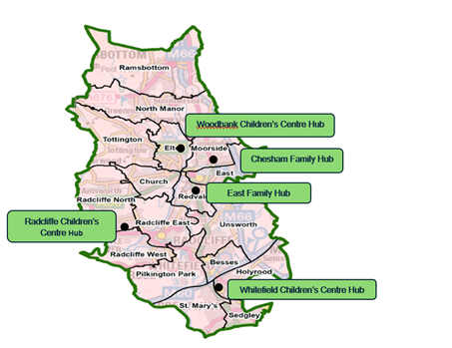
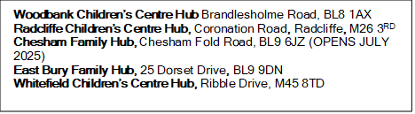
Bury Children’s Centres and Family Hub | Bury | Facebook

Our early help team also offer weekly drop-in sessions at various locations across the borough, so that parents, carers, grandparents or others! Can come in and speak to one of our trained practitioners who will be able to offer advice, guidance, and support, or sign post you to the right service who can help.

We can offer one-to-one advice on a range of topics such as:
- Parenting
- Mental Health
- School or college
- Finances
- Parental conflict
- Friendships
- Sexual health
- Domestic abuse
- Family relationships & difficulties
- Substance misuse
- Housing
- General worries or queries

