
Bury Safeguarding Partnership
Multi-Agency Request for Support Form
The Bury Multi-Agency Safeguarding Hub (MASH) provides practitioners and members of the public with advice, information, and support about the services available for children, young people and families who need additional support or who may be at risk of harm.

The Bury MASH aims:
- to work with children and families in Bury to support delivery of the right help to the right child, young person, and families at the right time.
- to work alongside families, building on their strengths and empowering them to bring positive outcomes and sustained change to their lives.

If you believe there is an immediate risk of harm, please contact the Police on 999 before making this referral to the MASH. If your request is urgent and outside of normal working hours (8:45am to 5pm Monday to Friday), please contact the out of hours team on 0161 253 6606.

Bury Safeguarding Children’s Partnership Continuum of Need
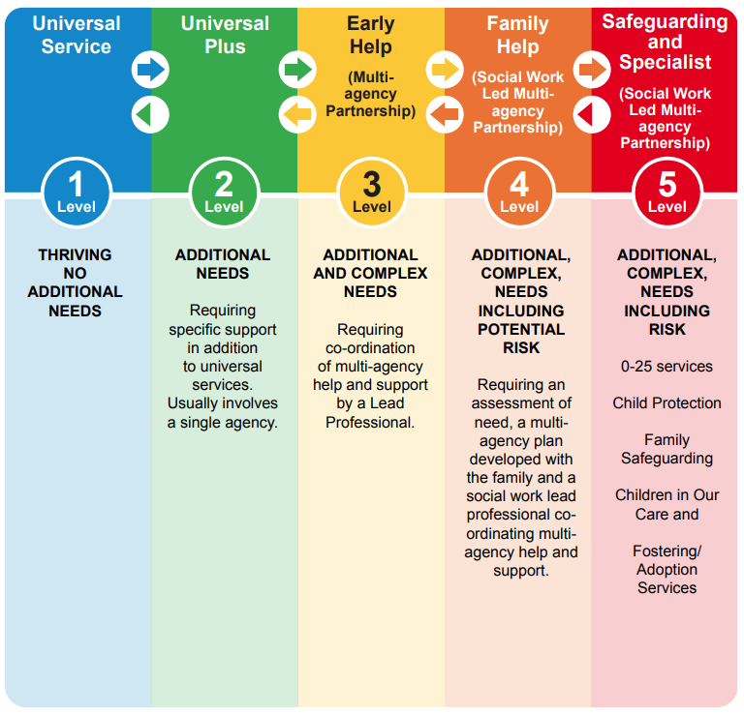
Request for Support
When completing this form, please provide as much information as possible to enable us to deal with your request quickly.
Please confirm the address of the child/children that this request for support relates to
         | The Bury Continuum of Need  Universal Service - Most children thrive and reach their full potential through the care of their families, communities, and universal services. Universal services are delivered through schools, primary healthcare, leisure services and voluntary services.  Universal Plus - Children, Young People and Families who have some needs unmet by Universal Services may need additional support to improve education, parenting and/or behaviour or to meet a specific physical or emotional health need. This may involve provision of additional help usually from a single agency. The provision of the additional services renders all needs met.  Early Help - Children, Young People and Families with additional and complex needs who need a co-ordinated multi-agency targeted response. They will be experiencing persistent problems which it has not been possible to resolve at Universal Plus. Maybe a child with a disability meeting threshold for assessment and requiring involvement of SEND and/or Graduated Response services – or maybe a child with an ASSET plus assessment in place.  Family Help - Children, Young People and Families whose needs have not been met at the preceding levels and a child who is unlikely to achieve or maintain, or have opportunity of achieving or maintaining, a reasonable standard of health or development without the provision of services by a local authority; a child whose health or development is likely to be significantly impaired or further impaired, without the provision of services; a child who has a substantial and permanent disability. A Lead Professional (social worker) will complete a statutory child and family assessment (s17) coordinate a child in need plan. Children who have caring responsibilities can request an assessment. A young carers transition assessment should be completed prior to 18th birthday.  Safeguarding and Specialist - Children and Young People whose needs have not been met at the preceding levels and who are at risk of/are suffering significant harm and/or at high risk of harm to self and others. Child Protection procedures should be followed where significant harm is due to the care afforded or not by parents. Young people who pose a risk to self or others may need either psychiatric or criminal pathway. If you believe there is immediate risk of harm, please contact the Police.
The following section must be completed.
Continuum of Need Judgement? |  | Choose an item
Has an Early Help (Story so Far) assessment been undertaken? |  | Choose an item
Is this a request for a CiN or CP transfer? |  | Choose an item

Referrer Details
Name
Job Title
Address

Telephone number (please be aware that you may be contacted for further information regarding this request for support)
Email address
Which service are you from?
Date and time of request for support

Consent and Information Sharing
As a professional working with the child/young person/family, it is your responsibility to speak with parents/carers about your concerns, unless doing so would place the child/young person at risk of significant harm. This principle is made explicit in Working Together 2023 guidance.
Consent is needed from families and young people at key points in their journey and can only be disposed of when there is an overriding concern for the welfare of children or families and their safety. Even when this is the case, only in exceptional circumstances should family’s details be discussed and shared with other agencies without their knowledge.
It is therefore an expectation to seek permission from the parent/carer to request services. It is critical to develop a co-operative working relationship from the outset (where possible), so that parents and caregivers feel respected and informed that professionals are being open and honest with them and they in turn are confident about providing vital information about their child/young person, themselves, and their circumstances.

Do parents/carers/young person (16+) give consent to this request for support? | Choose an item
If no, why has consent not been obtained?
Who has given consent and what is their relationship to the child/children?
Do parents/carers/young person (16+) give consent to share and gather information from partner agencies? | Choose an item

Children/Young Person requiring Support (1)
Forename(s)
Surname
Date of Birth or Expected date of birth
Is age estimated? | Choose an item
Address
Gender
Name of mother
Name of father
Name of education provision
Ethnicity
Is an interpreter required? | Choose an item
First Language
Religion
Communication Need/Special Needs or Disabilities. Is there an EHC Plan in place?
GP Surgery
GP Surgery telephone number
NHS number

Children/Young Person requiring Support (2)
Forename(s)
Surname
Date of Birth or Expected date of birth
Is age estimated? | Choose an item
Address
Gender
Name of mother
Name of father
Name of education provision
Ethnicity
Is an interpreter required? | Choose an item
First Language
Religion
Communication Need/Special Needs or Disabilities. Is there an EHC Plan in place?
GP Surgery
GP Surgery telephone number
NHS number

If there are more than two children/young people, please insert additional boxes.

Presenting Issues
Please indicate current concerns for each child/young person. Please tick all that apply.
Child behavioural issues |  | Parental drug/alcohol misuse
CAO/SGO application |  | Parental sexual offences
Children with disability |  | Physical abuse
Child sexual exploitation |  | Physical injury to child
Child criminal exploitation |  | Private Fostering (notification)
Domestic abuse |  | Radicalisation/Extremism
Emotional abuse |  | Request for information
Fabricated illness |  | Sexual abuse
Female Genital Mutilation (FGM) |  | Sexual harmful behaviour (CYP)
Forced marriage |  | Terrorism
Honour based violence |  | Trafficking/slavery
Knife enabled youth crime |  | Section 85 notification
16/17 Homelessness |  | Unaccompanied asylum seeker child
Midwives – unborn |  | Adoption/SGO breakdown
Missing from home |  | Child mental health/self-harm
Neglect |  | Child in Need transfer
No recourse to public funding |  | Child Protection transfer
Parental criminality |  | Homelessness/eviction
Parental drug/alcohol misuse

Siblings and other significant children not being referred
Forename(s)
Surname
Date of Birth or Expected date of birth
Address
Gender

Forename(s)
Surname
Date of Birth or Expected date of birth
Address
Gender

If there are more than two children/young people, please insert additional boxes.
Parents, carers, and other significant adults
Forename(s)
Surname
Date of Birth
Age (if date of birth not available)
Ethnicity
Address
Telephone number
Relationship to the child(ren) – please indicate which children the relationship applies to if referring more than one child.
Does this person have parental responsibility? | Choose an item

Forename(s)
Surname
Date of Birth
Age (if date of birth not available)
Ethnicity
Address
Telephone number
Relationship to the child(ren) – please indicate which children the relationship applies to if referring more than one child.
Does this person have parental responsibility? | Choose an item

Evidence for your Continuum of Need Judgement
What are the circumstances that have led to you making a request for support?

Has the child/young person been known to your Agency?  If yes, please provide a chronology of your agency’s involvement.  This should be no longer than 250 words. | Choose an item.
What actions have your agency taken to address specific concerns?

Which agencies are you aware of that are working with the child/ren and family?
Consider:
- Health Visitor/School Nurse
- GP
- Education
- Probation/Youth Offending
- Drug and Alcohol Services
- Mental Health
- Housing
- Adult Social Care

Please provide details, if known.

What’s working well? What are the family doing well?

What needs to happen to improve outcomes for child(ren) and family?

What Services does your Agency want for the family? What does this Service need to provide?

Voice of the child/young person
Parents/carers view

Please return completed form
The completed multi-agency referral form should be sent to the Bury MASH team via email to childwellbeing@bury.gov.uk
Consultation can be sought from a Duty Social Worker on 0161 253 5678.

