Mark Carriline
Executive Director of Children, Young People and Culture

Our Ref MC/BP
Your Ref
Date
Please ask for Bart Popelier
Direct Line 0161 253 6109
Direct Fax 0161 253 6011
Secure Email: notifications@bury.gcsx.gov.uk


All Directors of Children’s Services
Department for Children, Young People and Culture

18/20 St Mary’s Place, Bury
BL9 0DZ
www.bury.gov.uk
Electronic or fax service of
Legal Documents is not accepted

Dear Colleague

We would like to take this opportunity to advise you of the services and facilities that are available for children and young people who may be placed in Bury by other Local Authorities. We think it is important that we all play our part in safeguarding and improving outcomes for children and young people who are looked after or who have been adopted. To that end I hope you agree that we need to be advised by placing Social Workers of any particular vulnerabilities or risk factors.

Please circulate this information to relevant professionals in your area. We hope that the information will help you to understand and access the range of services that we have available in Bury.

Yours sincerely

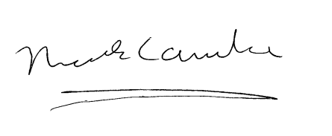

Mark Carriline
Executive Director
Children, Young People and Culture

