Referral for Oral Care to the Community Dental Service 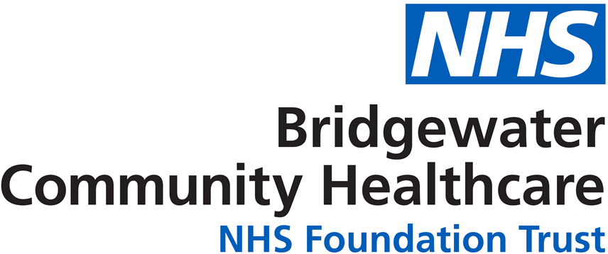
In Heywood, Middleton and Rochdale, Bury and Oldham

PATIENT DETAILS
First names  Date of birth  Address  Postcode  Interpreter Required?  Specify Language | ________________________________________________  ________________________________________________  ________________________________________________  Y / N  ________________________ |  |  |  |  |  | Surname  Age  Home Tel. No.  Contact Tel. No.  Gender (M/F)  NHS No.  School  (if appropriate) | ____________________________________________  ____________________________________________  ____________________________________________
REASON FOR REFERRAL (please tick all relevant categories):-

 | Behavioural problems/phobia |  | Trauma/broken teeth
 | Physical disability/Housebound |  | Sensory Impairment
 | Developmental or complex dental problems |  | Looked After Child/Child In Need
 | Learning Disability/Mental Health Needs |  | Dentures (lost/broken)
 | Other, please specify  __________________________________ |  | Medical

Have there been any episodes of pain? – Y/N (Please give details) _______________________________________________________________________________

_______________________________________________________________________________

URGENCY Urgent Routine
DENTAL HISTORY  Does the patient have a dentist? |  | Y / N | If Yes, give details (name and address of dentist/ date last seen):
Mobility Assessment: A domiciliary visit will be provided if required Please delete as appropriate.
Walks unaided  Walks with aid of stick/ frame/ carer  Able to access social activities e.g. trips |  |  |  | Yes  Yes  Yes | No  No  No | Wheelchair user  Hoist required  Bed bound  Transport by ambulance required |  |  | Yes  Yes  Yes  Yes | No  No  No  No
MEDICAL HISTORY  Details of relevant medical problems:  General Medical Doctor: Name and Address |  |  |  |  |  | Medication:  (Attach separate sheet if appropriate)

SOCIAL HISTORY

Details of legal guardian/regular carer/next of kin. Please include contact information.

NHS charges for dental treatment will apply unless patients are exempt from charges.

All referrals will be placed on our waiting list and will be contacted as appropriate.
Referrals assessed as urgent will be seen as soon as possible.

NAME AND CONTACT DETAILS OF REFERRER  Name : __________________________________  Address_________________________________  ________________________________________  ________________________________________  Postcode:________________________________  Telephone: ______________________________ | SIGNATURE:  DATE :

Please keep a copy for your reference and send to:

E-mail : bchft.oldham-communitydental@nhs.net

